**Experiment 4.1**

**Student Name:** Sahil Kaundal **UID:** 21BCS8197

**Branch:** BE CSE (Lateral Entry) **Section/Group:** 616/A

**Semester:** 6th **Date of Performance:** 20/03/2023

**Subject Name:** CC-2 Lab **Subject Code:** 20CSP-351

1. **Aim/Overview of the practical:**

Missing Number

Given an array nums containing n distinct numbers in the range [0, n], return the only number in the range that is missing from the array.

<https://leetcode.com/problems/missing-number/>

1. **Apparatus / Simulator Used:**

* Windows 7 or above
* Google Chrome

1. **Objective:**

* To understand the concept of Looping.
* To implement the concept of calculate the sum

1. **Code:**

class Solution {

public:

 int missingNumber(vector<int>& nums) {

 int ans=0;

 for(int i=0;i<nums.size();i++)

 {

 ans^=nums[i];

 ans^=i+1;

 }

 return ans;

 }

};

**4. Result/Output/Writing Summary:**

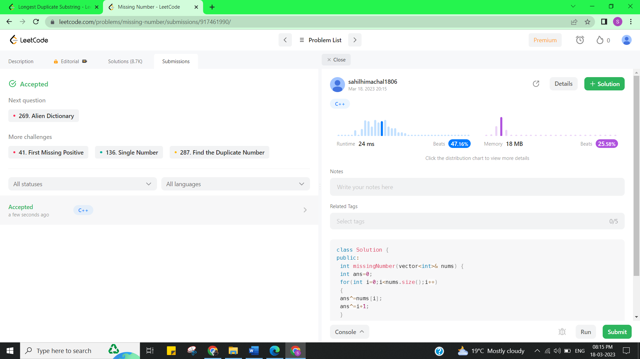

**Experiment 4.2**

1. **Aim/Overview of the practical:**

Longest Duplicate Substring

Given a string s, consider all duplicated substrings: (contiguous) substrings of s that occur 2 or more times. The occurrences may overlap.

<https://leetcode.com/problems/longest-duplicate-substring/>

1. **Apparatus / Simulator Used:**

* Windows 7 or above
* Google Chrome

1. **Objective:**

* To understand the concept of B Search
* To implement the concept of Rabin Karp.

1. **Code:**

class Solution {

public:

 string longestDupSubstring(string S) {

 ans = "";

 power = vector<int>(S.length(), 1);

 int i;

 for (i = 1 ; i < S.length(); i++) {

 power[i] = (power[i - 1] * 26) % prime;

 }

 int low = 0, high = S.length();

 while (low <= high) {

 int mid = low + (high - low) / 2;

 string tmp = validate(mid, S);

 if (tmp.length() == 0) {

 high = mid - 1;

 } else {

 if (tmp.length() > ans.length()) {

 ans = tmp;

 }

 low = mid + 1;

 }

 }

 return ans;

 }

private:

 int prime = 19260817;

 string ans;

vector<int> power;

 string validate(int desire, string &str) {

 if (desire == 0) return "";

 unordered_map<int, vector<int>> hash = unordered_map<int, vector<int>>();

 long long current = 0;

 int i;

 for (i = 0 ; i < desire; i++) {

 current = ((current * 26) % prime + (str[i] - 'a')) % prime;

 }

 hash[current] = vector<int>(1, 0);

 for (i = desire ; i < str.length(); i++) {

 current = ((current - (long long) power[desire - 1] * (str[i - desire] - 'a')) % prime + prime) %

prime;

 current = (current * 26 + (str[i] - 'a')) % prime;

 if (hash.find(current) == hash.end()) {

 hash[current] = vector<int>(1, i - desire + 1);

 } else {

 for (auto it : hash[current]) {

 if (strcmp((str.substr(it, desire)).data(), str.substr(i - desire + 1, desire).data()) == 0) {

 return str.substr(it, desire);

 }

 }

 hash[current].push_back(i - desire + 1);

 }

 }

 return "";

 }

};

1. **Result/Output/Writing Summary:**

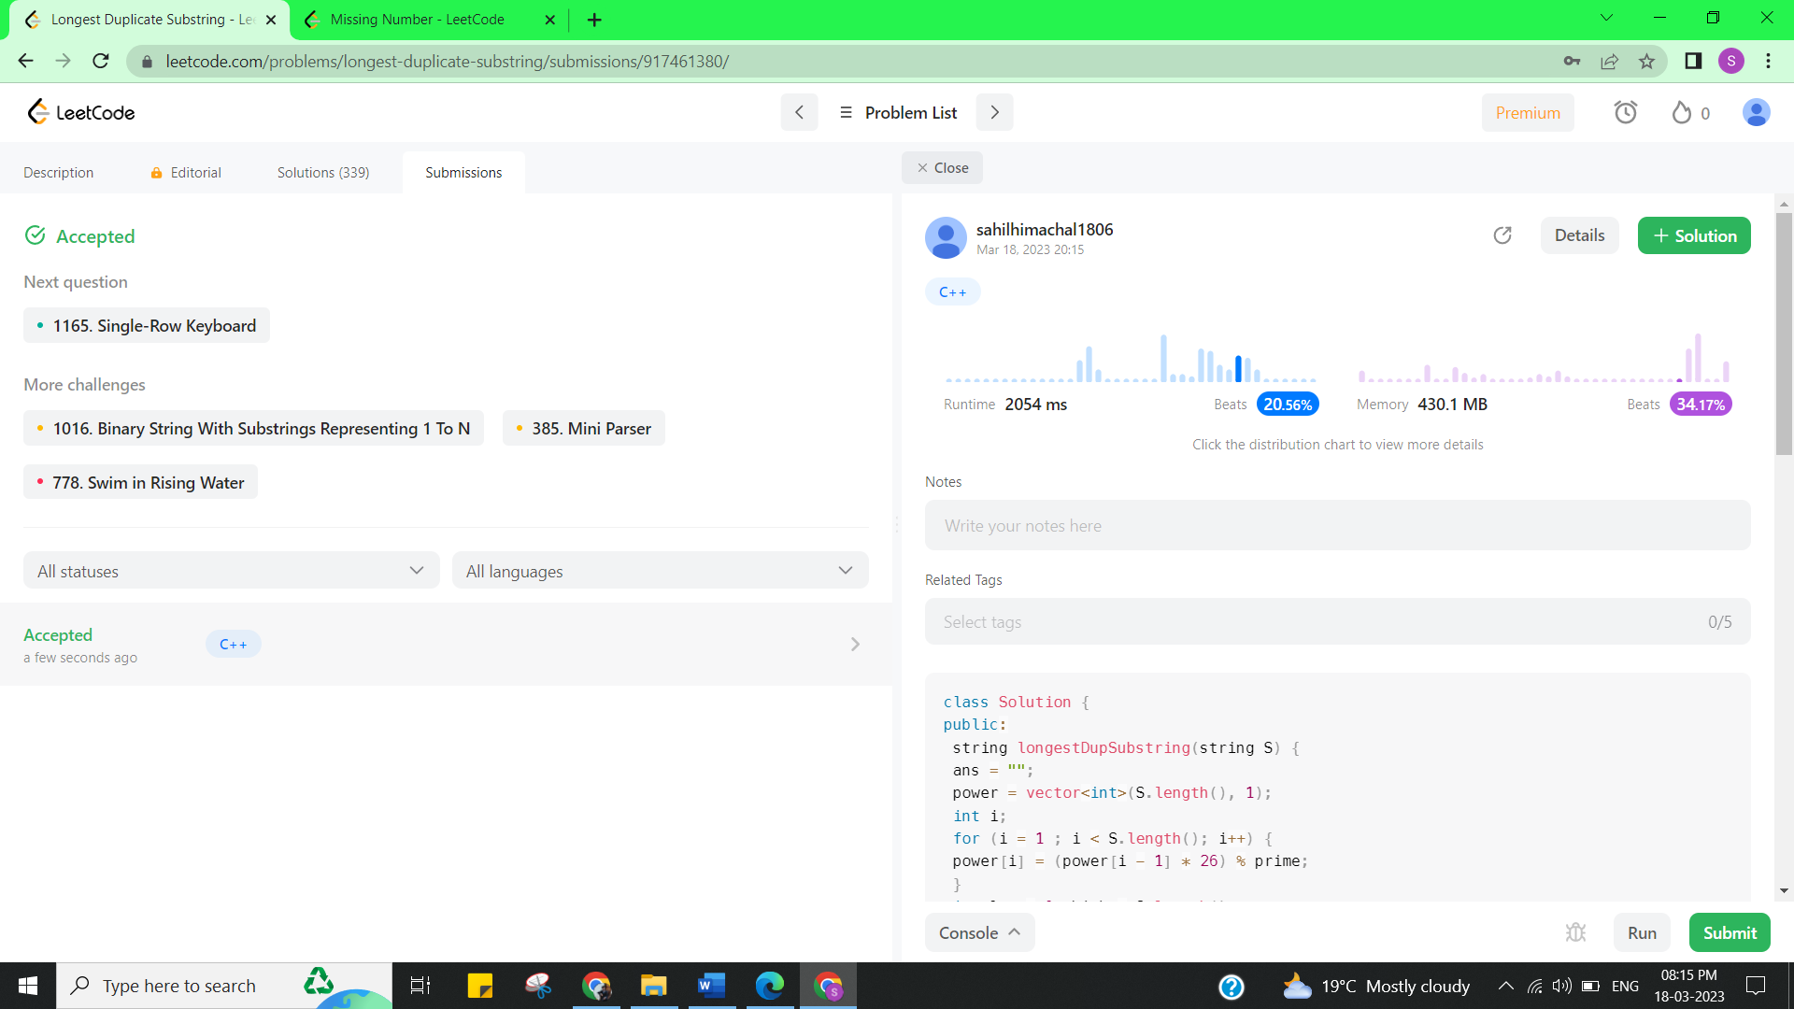

**Learning outcomes (What I have learnt):**

* Learned the concept of cheapest flights within k stops.
* Learnt about Array in Vector and Its iteration.

**Evaluation Grid (To be created as per the SOP and Assessment guidelines by the faculty):**

|  |  |  |  |
| --- | --- | --- | --- |
| Sr. No. | Parameters | Marks Obtained | Maximum Marks |
| 1. |  |  |  |